CCalculus 1 Lecture 4.1: An Introduction to the Indefinite Integral

Area Problems

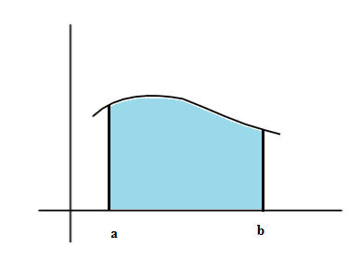

Two approaches to find the area under a curve
1 Rectangle method
2 Anti-derivative method

Rectangle Method
Divide [a,b] into “n” equal subsections in the shape of rectangles

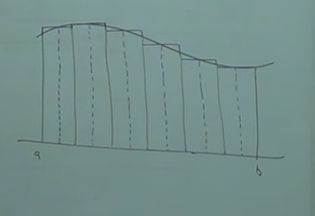

Sum up the areas of the rectangles from the area under the curve

For a better approximation make the space between each interval (the width of the rectangles) approach zero.

Anti-derivative Method
If A(x) is the area function for some f(x), on [a,b] then A’(x) = f(x)
This implies that to find the area under f(x) we must undo A’(x) to find A(x)

Example
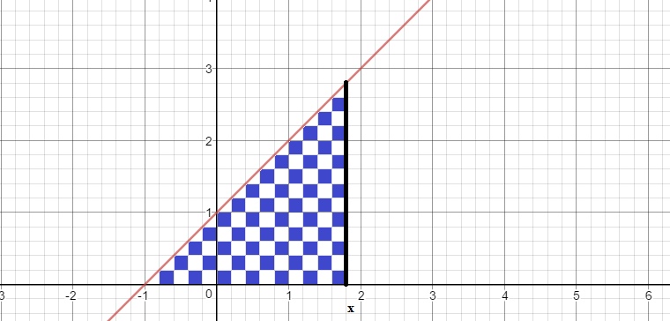
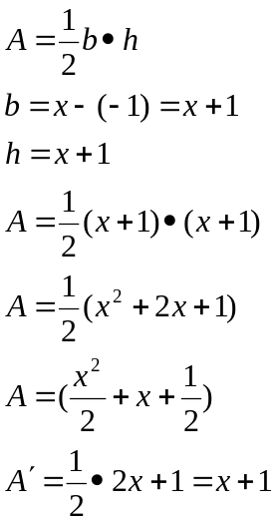

Example
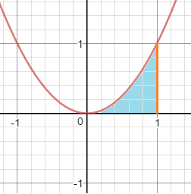
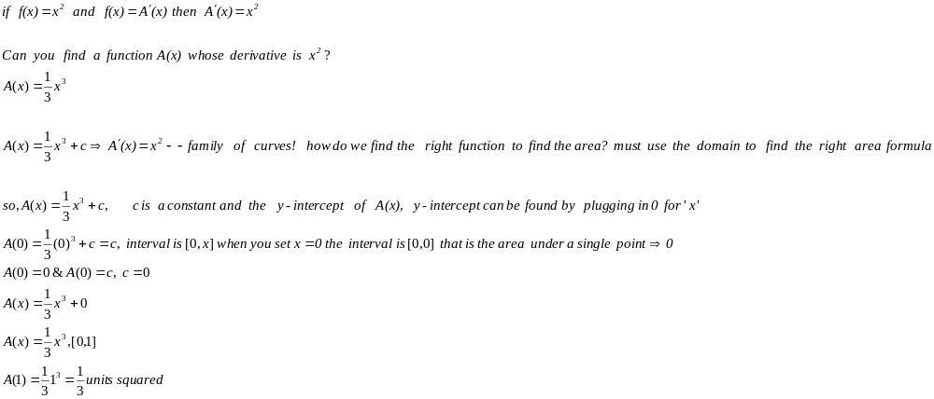
Indefinite Integrals
Formulas to find the area under a curve, but no definite solutions for the area.

Given a function, f, on some interval, I, F is called an anti-derivative (could be one of many) if 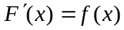

“F”=A(x) is the area function

Example
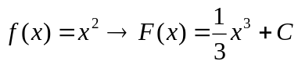
Antiderivative because
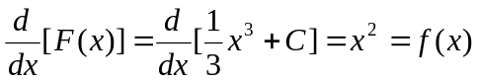

Process of finding the antiderivative is also called integration.
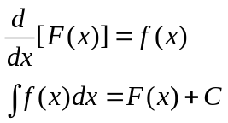

NOTE:
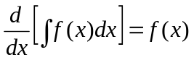

Example
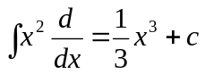

Basic Integration Table
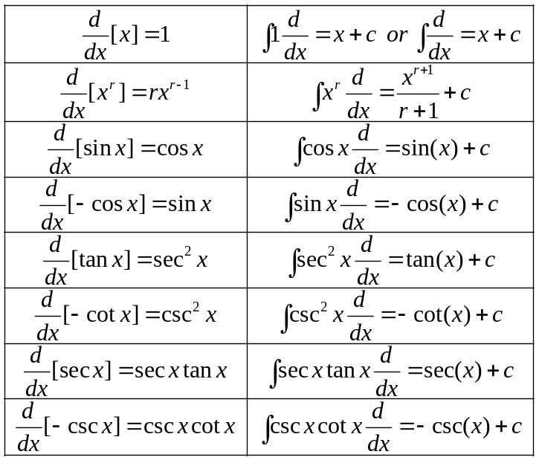

Example
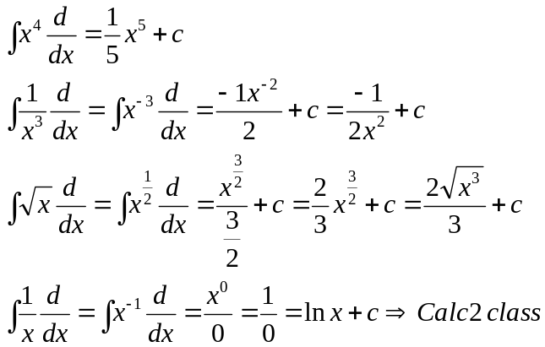

Properties
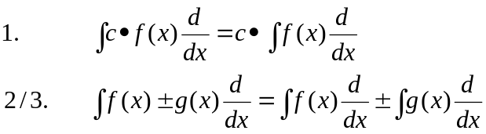

Example
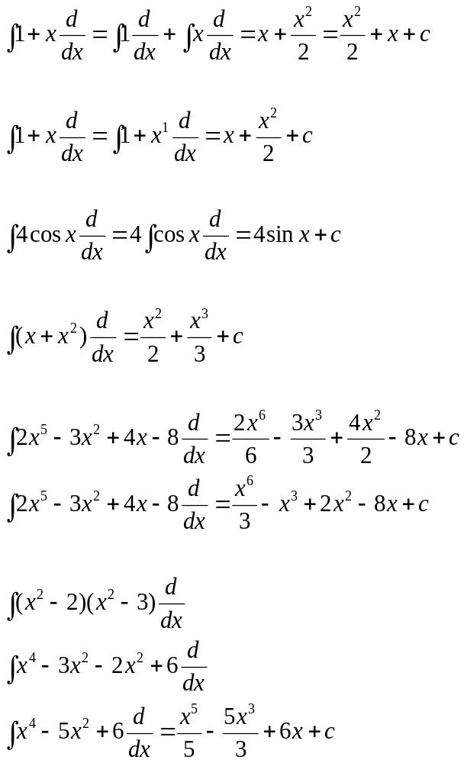

Example
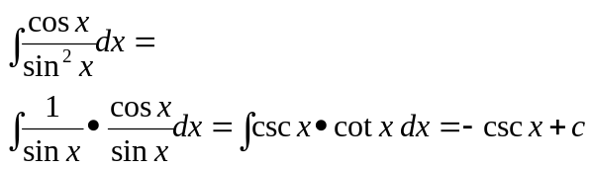

Example
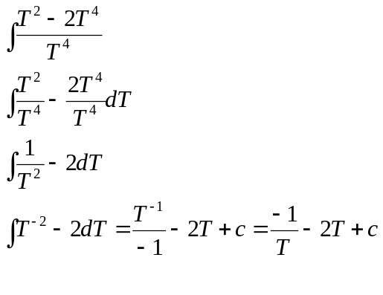
Example
Find the equation of a curve such that the slope at each point is 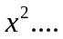
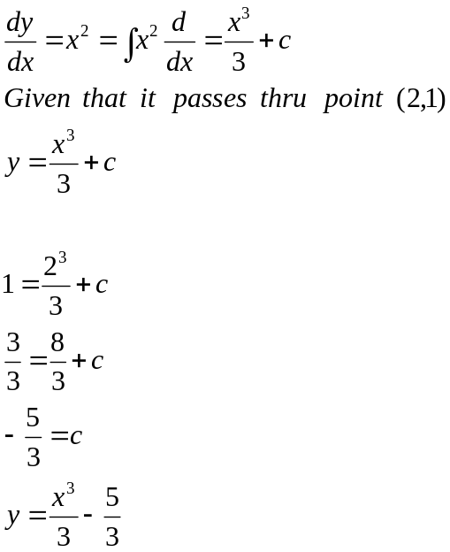

Differential equations
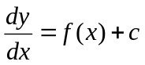

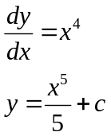

Initial Value Problem
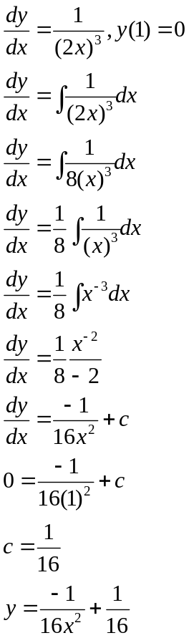

Initial Value Problem
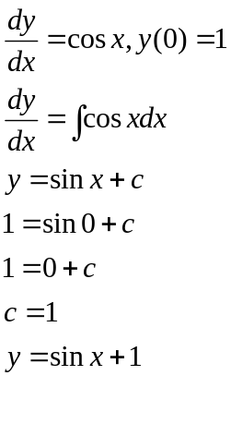

Catapult
Accidentally shoots straight up in the air with an initial velocity of 128 feet per second from a height of 16 ft
Find the position function for the height
Max height
When will it hit the ground.

